**STATE UNIVERSITY OF ZANZIBAR (SUZA)**



**DEPARTMENT OF COMPUTER SCIENCE AND IT**

**BLOCK TEACHING PRACTICE MANAGEMENT SYSTEM (BTP)**

**PARTICIPANT:**

**NAME: NURU ISSA SULEIMAN**

**REG_NO: BCS/12/17/251/TZ**

**SUPERVISOR NAME: MASSOUD HAMAD MMANGA**

**DECLARATION:**

I hereby declare that the project work entitled “**BLOCK TEACHING PRACTICE** **MANAGEMENT SYSTEM**” is a record of an original work done by me under the guidance of **Mr. Massoud H. Mmanga**. And this project work is submitted in the partial fulfilment of the requirements for the award of the Degree of Computer in a Computer Science. The result embedded in this thesis have not been submitted to any other University or Institute for the award of any degree or diploma.

**CHAPTER ONE:**

**Introduction**

This is a block teaching practice system that lecturers and students will use throughout the field, and this system will further assist BTP coordination team to facilitate BTP activities from registration up to the provision of results.

**Preliminary study**

Each school has its own needs and the number of students they need for the respective subjects.

Normally, students are registered using the google form in applying for a school, which allows a student to fill out a name, registration number, year of study, school choices (allow him/her to choose the first three school they want to attend), subject combination and phone number.

When the student completes the registration, he or she is waiting for the response of the selected school.

Each supervisor is assigned number of students to visit, and for the rest of the field the supervisor is required to visit his/her students twice.

And on the student side, each student has two supervisors to supervise him/her in two different subjects. In general, student is supervised four times by two supervisors for the whole field.

**Problem Statement**

**Not having a good data records:** The supervisor uses a book or plan paper to record a student’s marks when they go to inspect them, which result can cause the destruction of data either loosing of that data or other reasons.

**Consume more time**: TP coordinator record marks and aggregate all marks recorded by supervisor, all process done by using excel, which takes a lot of time to record marks of each student in a computer.

So It is difficult for BTP coordination team to process the results from all supervisor since the all process are done manually.

**Inability to know the school has met its requirements**: The problem is that many students choose popular schools which results students to exceed the number of students required to those schools.

**Does not indicate location:** Also its difficult for supervisor to know the location of the school of the students they want to inspect.

**Project solution and scope**

* The Suza Teaching Practice will offer a web application for students and teachers.
* **Scope:**
* System will enable the students to see which school needs trainer and which school will meet the trainer they need.
* As well as the system should provide a record of how often a student has been evaluated, and which teacher has inspected him or her.
* Also system lets the teacher know which students should check.
* System give the direction of the school the teacher wants to go to visit the student
* System provide a notification for the teacher the day before the visit day

**Main and specific objectives**

* **Main aim:**
* To design web application of teaching practice at SUZA that help the management in accessing field result.
* **Specific objectives:**
* Collect data
* Design database
* To provide an opportunity for the supervisors and students to interact with them in solving their teacher Practice problem through web based application.
* To create a system that will guide the teacher to know the location of the school

**Feasibility study:**

The main objectives of a feasibility study are to determine whether or not a certain plan of action is likely to produce the anticipated result, although is dedicated to showing the outcomes of specific actions, it should begin with an evaluation of the entire operation of Block Teaching Practice (BTP).

So in Block Teaching management system we discuss the following feasibility study aspects:

**Technical feasibility:**

The Block Teaching Practice we are required to measure the technical requirements that we will use in our system, such as high powered computer, sufficient internet and updated software that will make the system running smoothly and efficiently.

**Economic feasibility:**

In this aspect it will be general cost which will be used in my system in terms of installation, designing (database), implementation and also an operation.

**Operational feasibility:**

In terms of operational this project will be easy for user to use and understand, also the system is going to be well implemented to remove all the problems that PT coordinator and students faced with.

**CHEPTER TWO: METHODOLOGY**

Software development approach (Structured or Object Oriented).

**Structured.**

In my project I prefer to use structure software

Reasons.

* Structure programming is user friendly and easy to understand and to learn.
* Program written in a higher level language can be translated into many machine languages and therefore can run on any computer for which there exists an appropriate translator.
* It is independent of machine on which it is used, i.e programs developed in high level languages can be run on any computer.
* Structured programming helps to make isolated small pieces of code easier to understand without having to understand the whole program at once.
* Structured programming assists the programmer in writing effective errors free program

**System Development Life Cycle (SDLC).**

System Development Life Cycle is a process for planning, creating, testing, and deploying an information system. The SDLC concept applies to a range of hardware and software configurations, as a system can be composed of hardware only, software only, or a combination of both.

The aims of SDLC are to ensure that high quality system are delivered, provide strong management controls over the project, and maximize the productivity of the system staff.

In my system I will use Agile model for all processes to conduct my project.

**Agile Model:**

Agile method is the best process model in the System Development Life Cycle, is the software development model that encourages the continuous iteration of development and testing in the entire software development lifecycle of the project.

The main benefits of agile is that when we change the process or features regardless of the pans and terms, Customer will be happy and the end product will be delivered as expected.

Also enable collaboration (participation) between the teams and which results equal distribution of work as per the skills and availability of the stakeholders, which will make faster and quality delivery of software product.

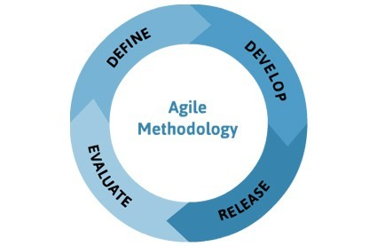

**System Architecture:**

In case of system architecture in my system I used 3-tier architectures that divided into three different parts that are:

**Client layer**

**Business layer**

**Data layer**

Client layer: It is also called as Presentation layer which contains UI part of our application. This layer is used for the design purpose where data is represented to the user or input taken from the user.

Business layer: In this layer all business logic written like validation of data, calculations, data insertion etc. This acts as an interface between client layer and Data Access layer.

Data layer: Contains methods to connect with database and to perform insert, update, delete, get data from database based on our input data.

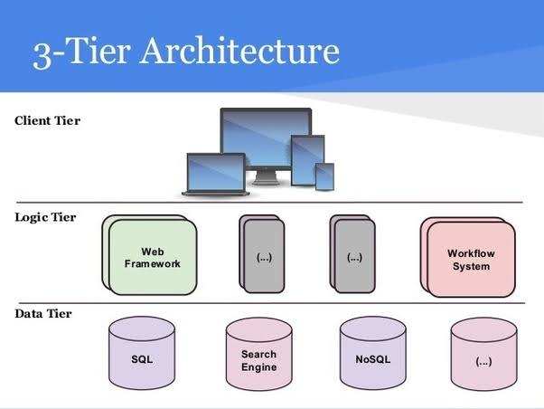

**Software Development Tools.**

Software Development tool is a computer program that software developers use to create, debug, maintain, or otherwise support other programs and application.

Example of software development tools that I can use are NetBeans, Notepad ++, PHP, Google chrome etc.

**CHAPTER THREE:** Requirements Analysis and Modelling

Requirement determination

**Information gathering technique:**

The information gathering techniques are repeated processes that are used to create and organize data across different kinds of sources. There are four types of information gathering techniques as follows:

Brainstorming, Delphi techniques, Root cause analysis and Interviewing.

In my project I use interviewing to get accurate and clear information from the PT students, PT coordinator and supervisors.

Among of the questions that I asked are:

* How the existing system works?
* There were any challenges you were facing due to the existing system.?
* How did you keep your data?
* Is it necessary to establish a new system?
* What feature do you think we should add to the new system?
* Do you think it will solve the problem facing in existing system?

**Functional requirement:**

Function requirement is describing the behaviour of the system as it relates to the system’s functionality.

A functional requirement describes what a software system should do.

A functional requirement defines a functionof a system or its component, where a function is described as a specification of behaviour between outputs and inputs.

In my project the function requirement includes:

* System should be register PT students, PT coordinators, and Schools.
* System should be enable the students to see which school needs trainer and which school will meet the trainer they need.
* System should provide a record of how often a student has been evaluated, and which teacher has inspected him or her.
* System should let the teacher know which students should check.
* System should give the direction of the school the teacher wants to go to visit the students.

**Non-functional requirement**

* System should be available anytime
* System should be very secure to avoid data inconsistence
* System should be made up with easy and friendly user interface
* System should perform in a highest point of performance

Requirement Structuring

Process Modelling:

Process modelling is a technique designed to understand and describe the process at the type level. Since the **process model** is at the type level, a **process** is an instantiation of it. It connects and improve the communication between the current and the future state of a process.

For Structured Approach: